Standard Operating Procedure (SOP): Data Request Processing
Audience: CHARM Data Management Team
Scope: Investigator-initiated data requests (analysis, manuscripts)
Objective: Ensure all data requests are processed in a standardized, reproducible, auditable, and high-quality manner.

1. Intake & Coordination
1.1 Monitor Requests
- Regularly check the ECHO Help Desk email for:
  - New data requests
  - Follow-up questions
  - Revisions or clarifications
- Communicate with Alexa to confirm:
  - IRB
  - Scientific purpose of the request
  - Cohort(s) involved
1.2 Task & Folder Setup
- Create a dedicated folder for the data request. All data pulls must be stored in a request-specific subfolder using the following structure:
  - Z:/ECHO/CHARM/Data/Data Pulls/{Requester}/{Requester_Date}/
  - Where:
  - {Requester} = last name of the requester
  - {Requester_Date} = {Requester}_{MMDDYYYY}
  - Example: Z:/ECHO/CHARM/Data/Data Pulls/Afroj/Afroj_01122026
  - Notes: make sure the date is intake date
- Save the original Data Request spreadsheet using the standard naming convention. The original request Excel file must be saved inside the request-specific folder using the following naming format:
  - {Requester}_{MMDDYYYY}_CHARMRequest.xlsx
  - Example: Afroj_01122026_CHARMRequest.xlsx
- Create a corresponding Asana task including:
  - Requester name
  - Date received
  - Due date
  - Cohort and visit scope
  - Notes on derived variables
  - Final delivery path

2. Data Request Excel File Quality Check (Pre-QA)
Before loading any data, review the Data Request Excel file carefully.
2.1 Variable Name Validation
- Ensure no leading or trailing spaces in variable names
- Ensure no commas or illegal characters
- Variable names must exactly match the data dictionary
2.2 Visit Information
- Every variable must include visit information
- Visit names must align with standard visit labels in the data dictionary
If formatting issues are found, return the file to the requester for correction before proceeding.

3. Environment Setup
3.1 Initialize R Environment
- Use the official Data Pull Template
  - The master Data Pull template is stored at: Z:\ECHO\CHARM\Data\Data Pulls\Data Pull Template.R
- For every new data request:
  - Copy the template file into the request-specific folder (DATA_PULL_FOLDER).
  - Rename the script using the following naming convention:
    - Code for {REQUESTER_NAME}_{REQUEST_ID_DATE} Data Request.R
    - Example: Code for Afroj_01122026 Data Request.R
- Clear workspace and set the working directory
- Update the CONFIG section at the top of the script before running the data pull.
  - Only need to update REQUESTER_NAME, REQUEST_ID_DATE, REQUEST_TITLE, PREPARED_BY.
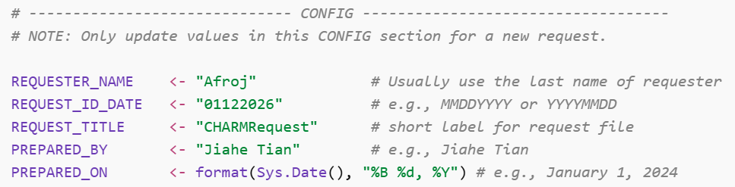
3.2 Load Data Request
- Record the file path of the data request
- Identify:
  - Whether an ID list is included
  - Which worksheet contains variables vs. IDs

4. ID Strategy
4.1 ID List Determination
- If an ID list is provided:
  - Restrict all data extraction to those IDs
- If no ID list is provided:
  - Use the full cohort ID list (MARCH / ARCH)
4.2 Mother–Child Crosswalk
- Load the Global Crosswalk
- Standardize ID fields:
  - mom_id
  - child_id
  - mom_echo_id
  - child_echo_id
- This crosswalk serves as the backbone dataset for all merges

5. Variable Preparation by Visit
5.1 Identify Required Visits
- Use the Visit column in the data request
- Summarize requested visits to determine required datasets
5.2 Load Raw Datasets
- Load datasets corresponding to each visit (e.g.):
  - Birth Certificate
  - Prenatal Survey 1 / 2
  - Postnatal surveys (by instrument and phase)

6. Standardized Variable Extraction
6.1 Use the Standard Function
All variable extraction must use the standardized function:
prep_requested_vars_by_visit()
This function:
- Filters requested variables by visit
- Checks variable existence in the dataset
- Returns:
  - Selected variables
  - Missing variables
  - ID availability diagnostics
- Renames ID fields to standardized names (mom_id, child_id)
6.2 Required Outputs
For each visit-specific extraction:
- selected: dataset ready for merging
- check: variable existence report
- missing: list of missing variables (for QA documentation)

7. Code-Derived Variables
7.1 When to Include
- Variables explicitly marked as Code Derived in the request
- Variables requested by investigators but not stored in raw datasets
7.2 Common Code-Derived Variables
- Plurality
- Maternal race
- Maternal age at birth
- Household income
- Gestational age at birth
- Dietary scores
Principles:
- Use standardized, team-approved source files
- Do not derive variables ad hoc within individual requests

8. Data Merging Strategy
8.1 Merge Order (Required)
- Mother–child crosswalk (ID backbone)
- Mother–child level data (e.g., birth certificate)
- Mother-level data
- Child-level data
8.2 Join Rules
- Use explicit join keys (mom_id, child_id)
- Always use left_join()
- Avoid unintended many-to-many joins (make sure check warnings)

9. Quality Assurance (Final QA)
9.1 Variable Completeness Check
- Verify that every requested variable appears in the final dataset
- Generate a QA table indicating:
  - Variable name
  - Presence in final dataset (TRUE/FALSE)
9.2 Resolve Issues
- Any missing variables must be:
  - Investigated
  - Documented
  - Explained in the Notes sheet or communicated to the requester

10. Data Delivery & Documentation
10.1 Output Format
- Deliver data as an Excel file using openxlsx
- Required worksheets:
  - Data
  - Notes
10.2 Notes Sheet Requirements
The Notes sheet must include:
- Data preparation date and preparer
- Explanation of excluded variables
- Description of code-derived variables
- Clarification of variable definitions where needed
- Definition of missing values (NA)
10.3 File Naming Convention
{Requester}_{YYYYMMDD}.xlsx

11. Close-Out & Record Keeping
- Save final dataset in the designated request folder
- Update Asana task status and notes
- Retain scripts and QA outputs for reproducibility

